Additional Information Windows

Geoff Anderson G3NPA

1.0 GENERAL

The main purpose of this section is to give the operator some brief and quick details that are related to the data entered in the Logbook Entry window and what is in your logbook. These windows are accessible ONLY via the "?" icons found in the Logbook Entry window. Please see the Logbook Entry window Basic Setup section for details on how to set up Information buttons.

Additional information is currently available for IOTA, US States, US Counties and Grid Squares only. If other ADIF input panels in the Logbook Entry window are set up with the "?" icon, then a "Not Coded Yet" message will appear when selected.

2.0 IOTA INFORMATION WINDOW

The picture below shows that the cursor has been placed over the IOTA information access button.

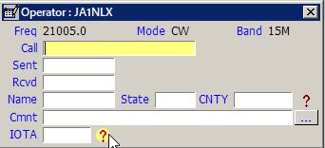

New AIW_1

To use the additional information, enter a callsign and the IOTA number into the appropriate edit boxes in the Logbook Entry window and then click on the IOTA "?" icon. This will bring up the IOTA Additional Information window advising the log status of the particular island group (see typical panel below). In this case, the Title bar is telling the operator that EU-006 is needed.

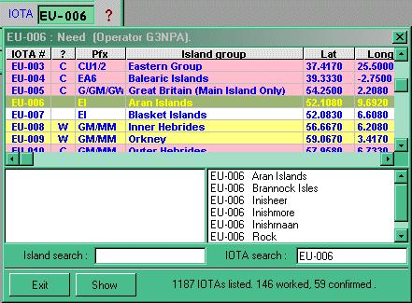

AIW_2

The messages that appear in the Title bar will indicate “Worked”, “Confirmed” or “Need”.

As IOTA credits are neither band nor mode conscious, the information reflects the general state of the log for a particular IOTA group. If more specific band/mode information is required, then consult the IOTA awards table.

Note that the IOTA search has been set to EU-006 and the highlight placed in the correct position in the table.

The window shown above may be used to carry out searches for islands or groups. Typing in a word in the Island search will give island names that most closely match what you have entered in the left-hand pane. Alternatively, one can enter the known island IOTA code and all the known islands in that group will be displayed (note that this will depend on what you have entered into the main database). In the picture below the Island of "Belli" has been entered and by clicking on the name in the left pane, two things will happen. First, all the islands listed in that group will appear in the right-hand pane and second, the main title will be highlighted in the listing. In the case below, the highlighting is in yellow with a red script (but this is user-definable). The light red and light yellow highlights show island groups confirmed and worked (again these highlight colors are user-definable).

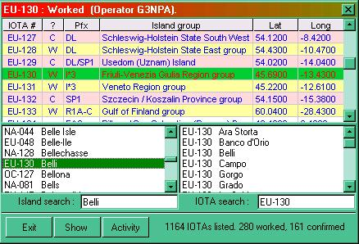

AIW_3

Having highlighted an IOTA reference, you can now click on the <Show> button to produce a map with the nominal center of the island group marked as shown below. In the picture below, the island group is denoted by a small yellow square just at the northern end of Italy.

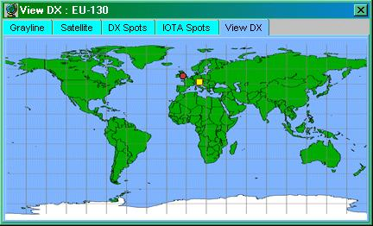

AIW_4

Once this map is displayed, you can select any island group from the table above and the island marker will move to the appropriate location.

The map size can be changed to suit by using the normal operating system facilities for resizing a window.

By right-clicking on the map itself you can get at the menus for customizing the map, all of which are self-explanatory. You can change the map itself to something more appropriate and/or modify the island marker both for size and color. See the topic Background Maps.

The <Activity> button will produce a table of data derived from the RSGB IOTA web site. See the Utilities topic for more information.

3.0 US STATE, US COUNTY AND GRID SQUARE INFORMATION WINDOWS

The US State, US County and Grid Square information windows all work in a similar way as described above. Some examples are shown below.

3.1 US State Information Window

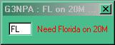

AIW_5

3.2 US County Information WIndow

In the case of US counties, the information window has an additional facility in that the whole list of counties will be searched for a match as you type in a name. Clicking on any of the counties presented will give something similar to the info window shown on the right below.

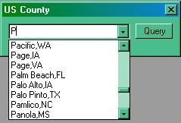

AIW_6

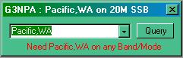

AIW_7
AIW_6 AIW_7

3.3 Grid Square Information Window

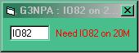

AIW_8

